
2016


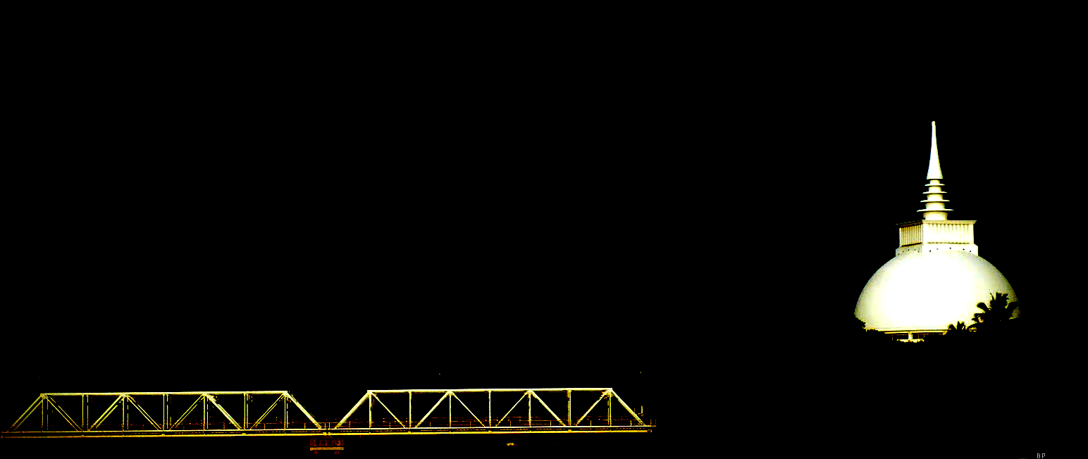
Open International Rating Chess Championship 2016

Organized by
KALUTARA CHESS CLUB

On behalf of the
CHESS FEDERATION OF SRI LANKA, ASIAN CHESS FEDERATION AND FIDE

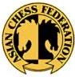




FROM 12TH TO 18TH JANUARY 2016
AT KALUTARA TOWN HALL
KALUTARA SOUTH , SRI LANKA

KALUTARA CHESS FESTIVAL - IV
OPEN INTERNATIONAL RATING CHESS CHAMPIONSHIP 2016
Kalutara Chess Festival Open International Rating Chess Championship 2016 organized by the Kalutara Chess Club, on be half of the Chess Federation of Sri Lanka and FIDE will be held at the Kalutara Town Hall, Kalutara from 12th (Arrival) to 18th (Departure) of January 2016 with a total cash prizes of nearly Rs. 325,000/= worth.

Venue : Kalutara Town Hall, Kalutara South, Sri Lanka.
Schedule : 12th January 2016 Arrival
13th January 2016 Round 1 & 2 9.00 am - 1.00 pm & 3.00 pm - 7.00 pm
14th January 2016 Round 3 & 4 9.00 am - 1.00 pm & 3.00 pm - 7.00 pm

15th January 2016 Round 5 & 6 9.00 am - 1.00 pm & 3.00 pm - 7.00 pm

16th January 2016 Round 7 & 8 9.00 am - 1.00 pm & 3.00 pm - 7.00 pm
17th January 2016 Round 9 & PDF 9.00 am - 1.00 pm & 4.00 pm - 6.00 pm
18th January 2016 Departure
Eligibility : Open for all

Prizes

Overall
Champion - Trophy + Gold Medal +
Rs. 60,000/=
1st Runner up - Silver Medal +Rs. 40,000/=
2nd Runner up - Bronze Medal +Rs. 25,000/=
4th&5thPlaces - Rs. 10,000/= each
6th to 10th Places - Rs. 5,000/= each

Best Girls
Champion - Trophy + Gold Medal +
Rs. 10,000/=
1st Runner up - Silver Medal + Rs. 6,000/=
2nd Runner up - Bronze Medal + Rs. 4,000/=

Best Player - Rating category 1700 to 1900
Champion - Gold Medal & Rs. 5,000/=
1st Runner up - Silver Medal & Rs. 3,000/=
2ndRunner up - Bronze Medal & Rs. 2,000/=

Best Player - Rating category 1500 to 1700
Champion - Gold Medal & Rs. 5,000/=
1st Runner up - Silver Medal & Rs. 3,000/=
2ndRunner up - Bronze Medal & Rs. 2,000/=

Best Player - Rating category 1300 to 1500
Champion - Gold Medal & Rs. 5,000/=
1st Runner up - Silver Medal & Rs. 3,000/=
2ndRunner up - Bronze Medal & Rs. 2,000/=

Best Player - Rating category less than 1300
Champion - Gold Medal & Rs. 5,000/=
1st Runner up - Silver Medal & Rs. 3,000/=
2ndRunner up - Bronze Medal & Rs. 2,000/=

Best Unrated Player
Champion - Gold Medal & Rs. 5,000/=
1st Runner up - Silver Medal & Rs. 3,000/=
2ndRunner up - Bronze Medal & Rs. 2,000/=
Best Under 15 Boys & Girls separately
Champion - Gold Medal & Rs. 5,000/=
1st Runner up - Silver Medal & Rs. 3,000/=
2ndRunner up - Bronze Medal & Rs. 2,000/=

Best Under 13 Boys & Girls separately
Champion - Gold Medal & Rs. 5,000/=
1st Runner up - Silver Medal & Rs. 3,000/=
2ndRunner up - Bronze Medal & Rs. 2,000/=

Best Under 11 Boys & Girls separately
Champion - Gold Medal & Rs. 5,000/=
1st Runner up - Silver Medal & Rs. 3,000/=
2ndRunner up - Bronze Medal & Rs. 2,000/=

Best Under 09 Boys & Girls separately
Champion - Gold Medal & Rs. 5,000/=
1st Runner up - Silver Medal & Rs. 3,000/=
2ndRunner up - Bronze Medal & Rs. 2,000/=

Best Under 07 Boys & Girls separately
Champion - Gold Medal + Chess Board
1st Runner up - SilverMedal + Chess Board
2ndRunner up - Bronze Medal + Chess Board

All the Participants will be provided with Participation Certificates. Only one prize is eligible for each winner.

Accommodation :
All the Foreign players with more than 2200 ELO Rating will be provided accommodation with three meals. All foreign players with more than 2000 ELO rating will be provided accommodation. All other foreign players have to look after their accommodation. We may support all on the request. All those who needs A/C Accommodation has to pay an extra fee of 50 $ per night. GMs,WGMs,IMs,WIMs may contact the organizers directly. All the foreign unrated players and accompanying person have to bare their own expenses.
Travel Grant :
GMs, IMs, WGMs, WIMs having over 2300 ELO (2200 for Women) will be given a travel grant of Sri Lankan Rs.12,000/=

Entries :
Dead line for entries is 10th January 2016 to the undersigned. Only 400 players will be registed for this event on the first come 1st serve basis. So even the rated players are requested to register early.You may hand over the entries with relevant fee to the following regional officials

Mr.Naditha Amarakoon (Colombo) 0775792372 Mr.Werochana Perera (Kurunegala) 0717400249
Mr.Rajeendra Kalugampitiya (Kandy) 0715601237 Mr.Jagath Ketalawala (Kegalle) 0715130654
Mr.Rajeev Thilakarathne (Polonnaruwa) 0776221847 Mr.Thejan Rathnayake (Colombo) 0713138301
Mrs.Buddhi Panagoda (Gampaha) 0719295352 Mr.Dulanga Dilhan (Matara) 0712535916
Mr.Gihan Perera (Galle) 0714498167 Mr.Melon Vonhagt (Panadura/Horana) 0775072940
Mr.Sanjula Ravinat (Rathnapura) 0719020600 Mr.Asela Hemantha (Galle) 0777337632
Mr.Dilan Isuru (Mathugama/Panadura) 0716630870 Mr.Thusitha Kumara (Kalutara/Horana) 0726022964
Mr.C S Kumarawadu (Moratuwa/Panadura)0712425763 Mrs.Nelum Samarasekara (Moratuwa) 0728036986

Entry Fee :
All title players over (GM,WGM,IM,WIM,FM,WFM) and rating above 2200 are free.

Rated players 1800 - 2000 : Rs. 2,000/=
Rated players below 1800 : Rs. 2,500/=
Unrated players : Rs. 3,500/=
- All amounts are in Sri Lankan Rupees.

All Inquiries & entries to :

Mr.Sumal Horawalavithana (FA/NI)
Hony. Secretary
Kalutara Chess Club
Asiri Uyana, Palatota,
Kalutara South. Sri Lanka.
Telephone(+94)0714-274432/(+94)071-9945955
E-mail: kalutara_chess_club@yahoo.com
Mr.Dayal Siriwardena (FA/NI)
President
Kalutara Chess Club
24,Sri Dharmarama Road,Katukurunda,
Kalutara South. Sri Lanka.
Telephon (+94)071-8560211/(+94)077-3456753
Email : dayal.chess@yahoo.com

For Further Clarifications
Mr. Luxman Wijesuriya (IA/FI)
Tournament Secretary - Chess Federation of Sri Lanka
General Secretary - Commonwealth Chess Association
Telephone: (+94)071-5397829

- Local Players without having a CFSL Registration will not be allowed to play in the event.

Be a part of this historical Chess event !!!

Mr.Sumal Horawalavithana.
Hony. Secretary
Kalutara Chess Club
Sri Lanka.
kalutara chess festival - IV
OPEN INTERNATIONAL RATING CHESS CHAMPIONSHIP 2016
Organized by
Kalutara Chess Club on behalf of the Chess Federation of Sri Lanka & FIDE
On 12th - 18th January 2016 at Kalutara Town Hall, Kalutara
ENTRY FORM

Full Name : ………………………………………………………………………………………………
School /Club : ………………………………………………………………………………………………
Address : ………………………………………………………………………………………………
E-mail : ………………………………………………………………………………………………
Contact No : ………………………………………………………………………………………………
Date of Birth : …………………………………. Sex : ………………………………………
FIDE Rating : …………………………………. FIDE ID : ………………………………………
I abide by the rules and regulations of the Event. All the Details given above are true to the best of my knowledge.

Player’s Signature : ……………………………. Date : ……………………………….

